**BOMBO PARENTS NURSERY AND PRIMARY SHOOL**

**END OF TERM II EXAMINATION 2023**

**Age Group (4 – 5 years): TOP CLASS**

**Learning Area 2: English**

My name is __________________________________________

1. **Circle the given letter.**

|  |  |
| --- | --- |
| g | l m g |
| h | o k h |
| l | i p l |
| k | o k l |
| s | s w t |

**2.Match the same.**

fire nail

broken bottle safety pin

safety pin fire

thorn broken bottle

nail thorn

1. **Circle the correct word for the picture.**

circle cup

tin chair

pot cup

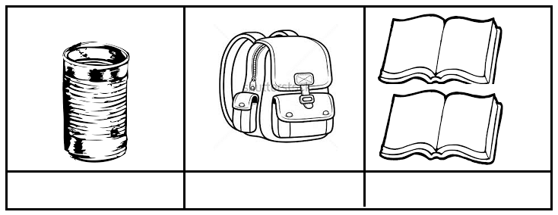

tree bag



mat book

1. **Complete the sentences.**

It is a bag.

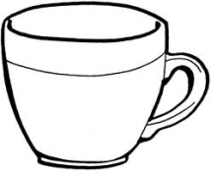

It is a ________________

It is a ________________



It is a _______________

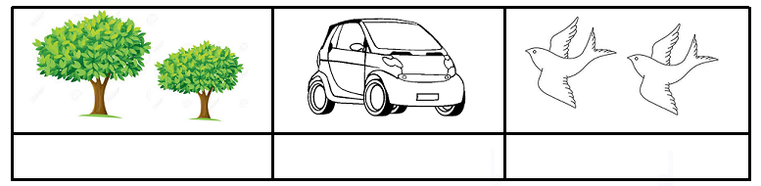

It is a _______________

(tree, box, cup, book, bag, ball)

1. 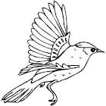**Match and name.**

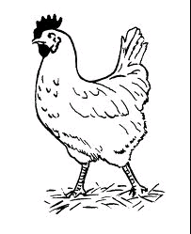

___________

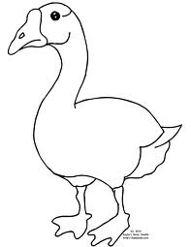



___________

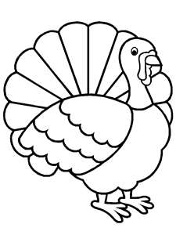

___________



 ___________

(dove, turkey, hen, duck)

**End**